

**Experiment - 2**

**WEATHER MODELLING USING QUADRATIC EQUATION**

**Software Engineering**

**By**

**Vulasala Sujan (BU22CSEN0101959)**

**Meti Chaitanya (BU22CSEN0101523)**

**Maraka Ganesh (BU22CSEN0101803)**

**J Bhargav Reddy (BU22CSEN0101198)**

**Under the Guidance of**

**Kerenalli Sudarshana (700542)**

**Gandhi Institute of Technology and Management**

**(DEEMED TO BE UNIVERSITY)**

**BENGALURU, KARNATAKA, INDIA**

**Academic Year 2024-25**

**INDEX**

* **Aim**
* **Algorithm Development**
* **Execution**
* **Result**

**Aim: -** To implement weather modelling using the quadratic solution across three software development approaches:

1. **Waterfall Model**: Sequential implementation of stages.
2. **Iterative Model**: Incremental development with refinements at each iteration.
3. **Agile Model**: Collaborative and adaptive development in sprints.

The implementation includes:

* Hard-coding variables.
* Keyboard input.
* File input for a single set of data.
* File input for multiple sets of data.
* All versions will be tested, debugged, and managed using GitHub for version control.

**Algorithm Development: -**

1. **Waterfall Model**
   1. **Step 1**: Analyse and finalize requirements for the weather modelling system.
   2. **Step 2**: Design the solution and prepare the algorithm for quadratic modelling.
   3. **Step 3**: Implement Version 1 (hard-coded variables). Test and debug the solution.
   4. **Step 4**: Implement Version 2 (keyboard input). Test and debug the solution.
   5. **Step 5**: Implement Version 3 (file input for a single set of data). Test and debug the solution.
   6. **Step 6**: Implement Version 4 (file input for multiple sets of data). Test and debug the solution.
   7. **Step 7**: Deliver the final product and document the entire process.
2. **Iterative Model**
3. **Step 1**: Identify the core functionality (quadratic modelling with hard-coded variables) and implement Version 1.
4. **Step 2**: Test Version 1 and refine based on feedback.
5. **Step 3**: Add Version 2 functionality (keyboard input) as the next iteration. Test and debug.
6. **Step 4**: Extend to Version 3 (file input for a single set of data). Test and refine.
7. **Step 5**: Extend to Version 4 (file input for multiple sets of data). Test and refine.
8. **Step 6**: Deliver the system incrementally, ensuring thorough testing and feedback at each stage.
9. **Agile Model**
10. **Sprint 1**: Develop Version 1 (hard-coded variables) and conduct a team review.
11. **Sprint 2**: Implement Version 2 (keyboard input), test, and adapt based on feedback.
12. **Sprint 3**: Extend to Version 3 (file input for a single set of data) with collaborative team effort.
13. **Sprint 4**: Extend to Version 4 (file input for multiple sets of data) and conduct final testing.
14. Deliver the product incrementally after every sprint. Use retrospective meetings to refine the process.

**Execution: -**

**1)Waterfall Model: -**

**a) Version 1(Hard coding variables): -**

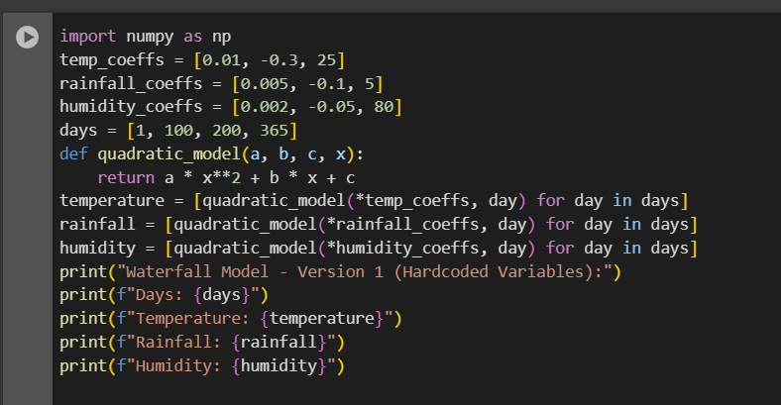

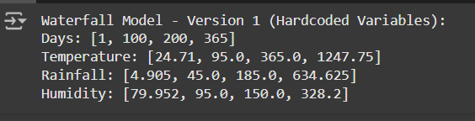

**b) Version 2 (Keyboard Input): -**

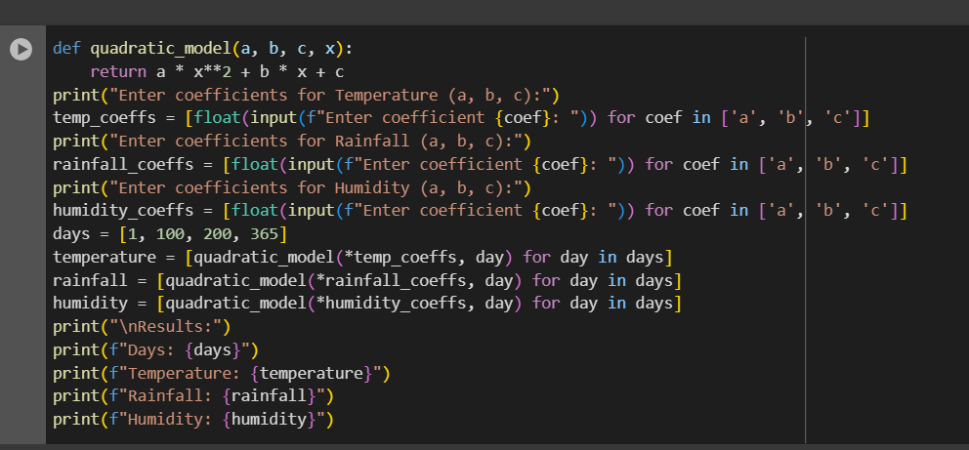

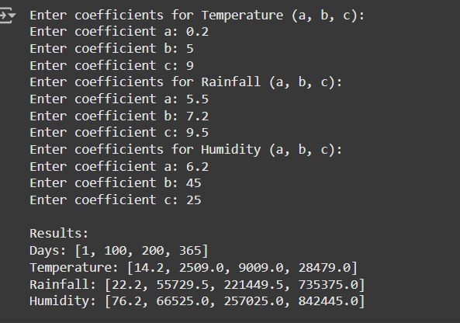

**c) Version 3 (Single set of data): -**

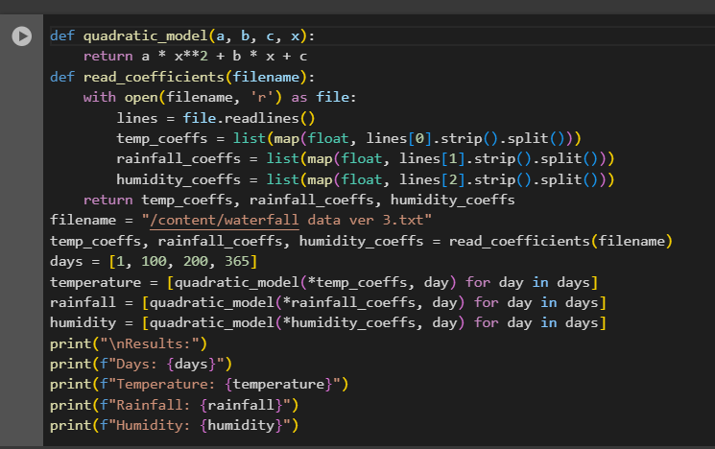

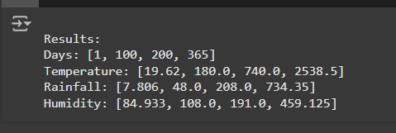

**d) Version 4 (Multiple sets of data): -**

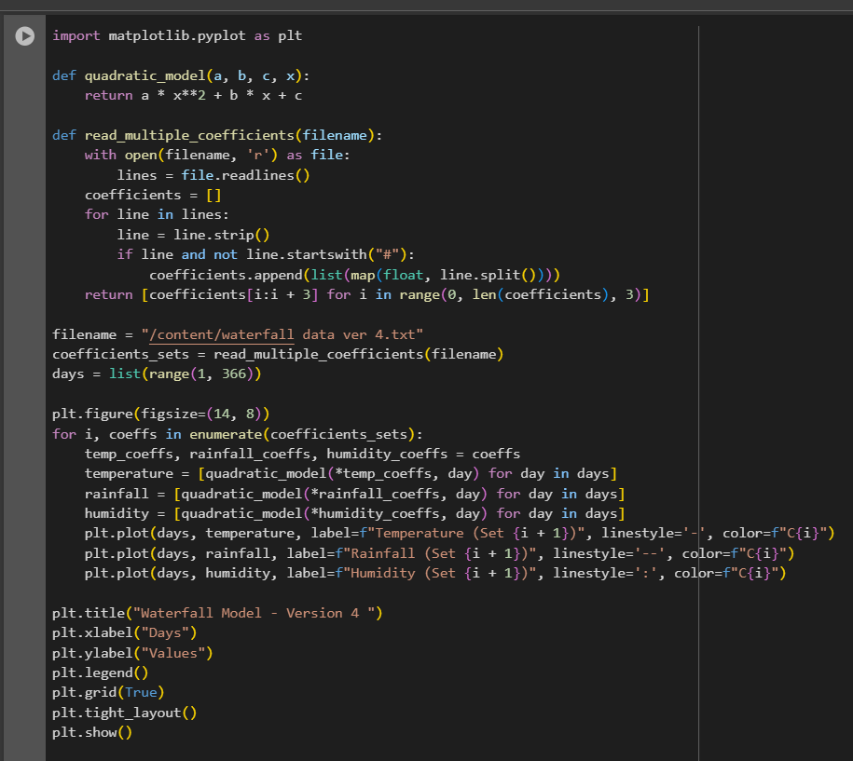

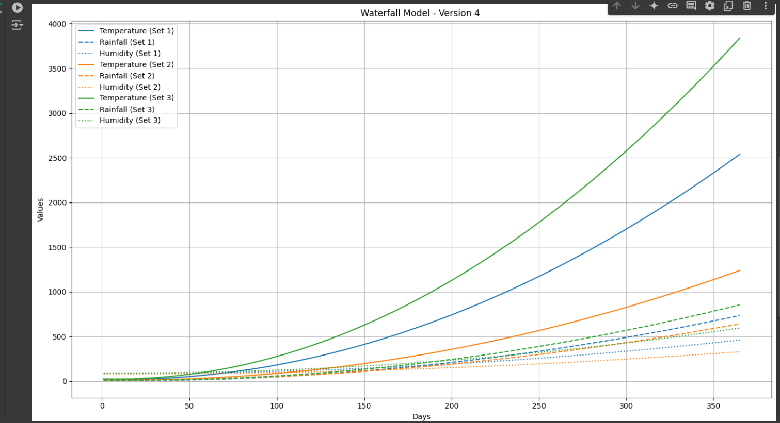

**GitHub Commit History: -**

**Version 1: -**

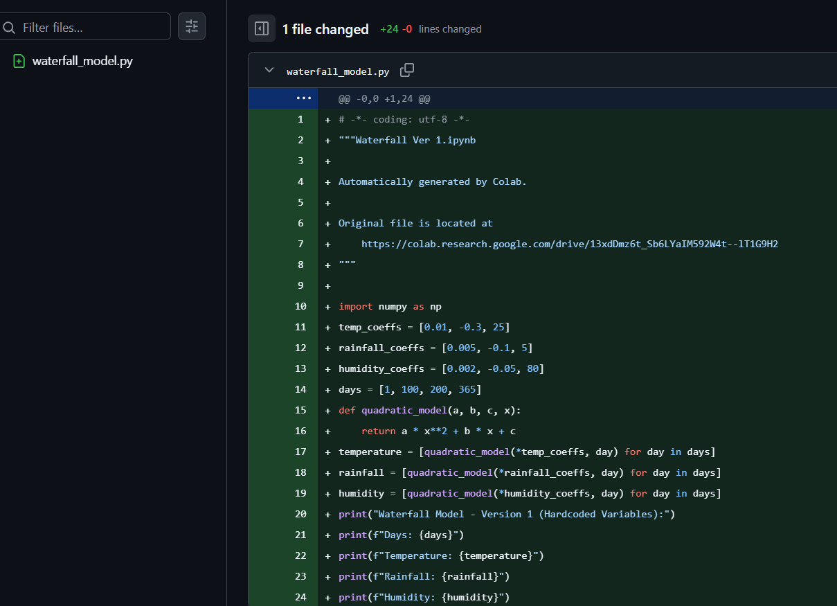

**Version 2:-**

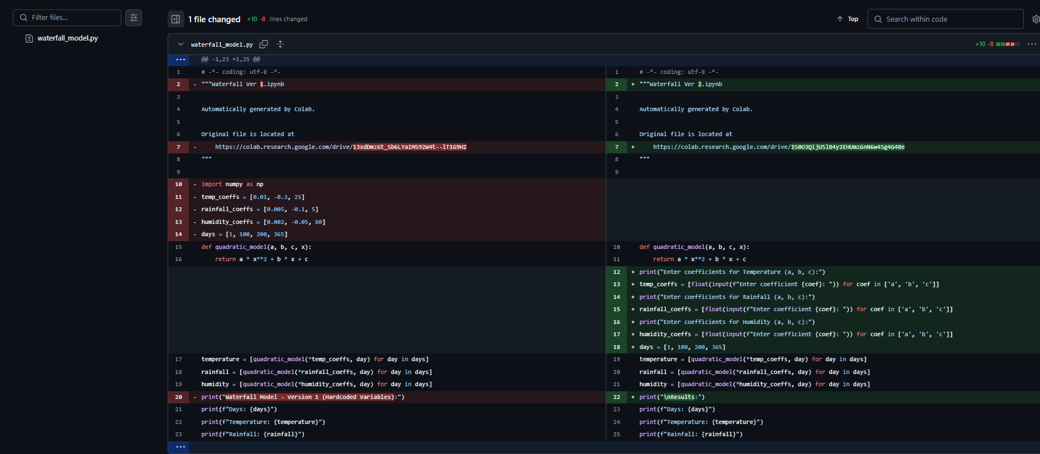

**Version 3:-**

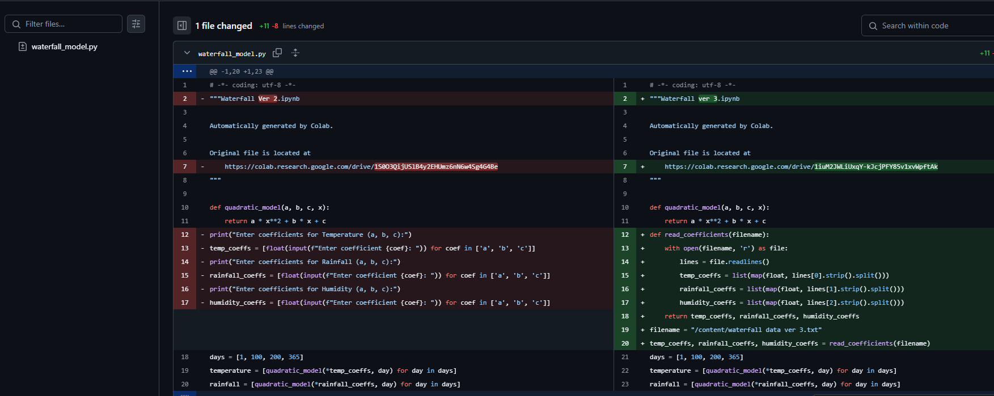

**Data ver 3:-**

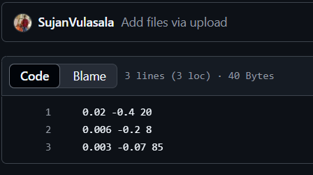

**Version 4:-**

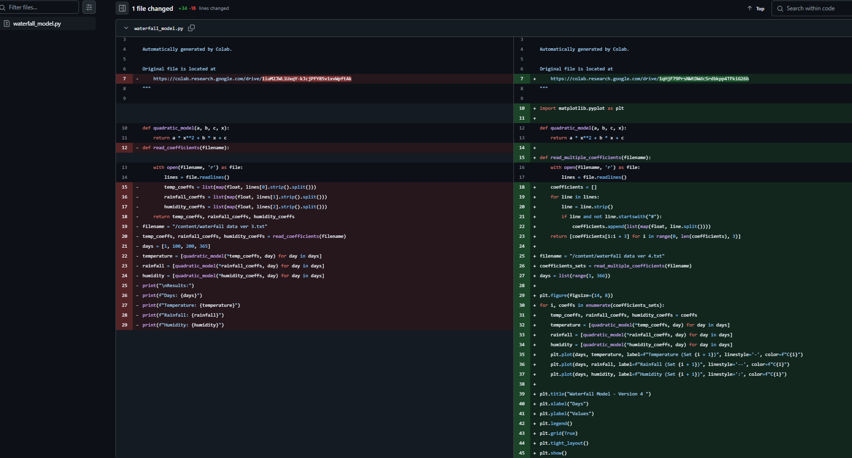

**Data Ver 4:-**

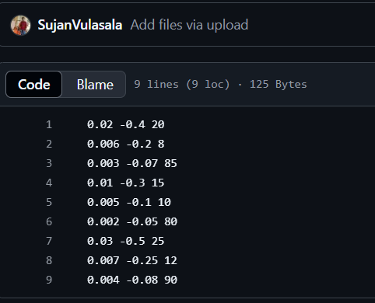

**2)Iterative Model :-**

**a)Version 1(Hard coding variables):-**

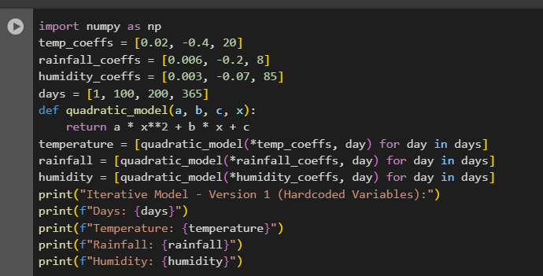

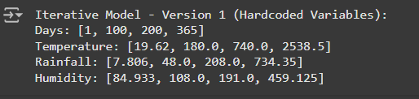

**b)Version 2 (Keyboard Input) :-**

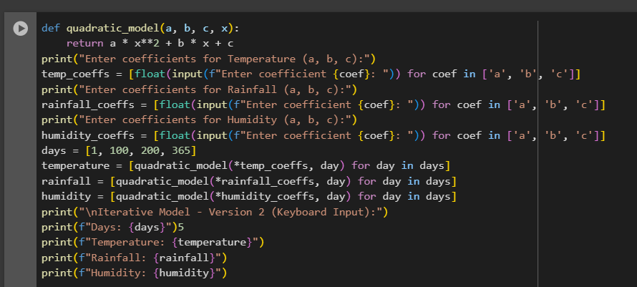

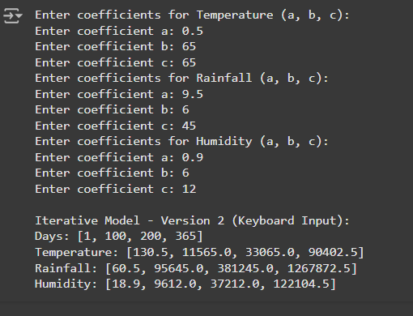

**c)Version 3 (Single set of data):-**

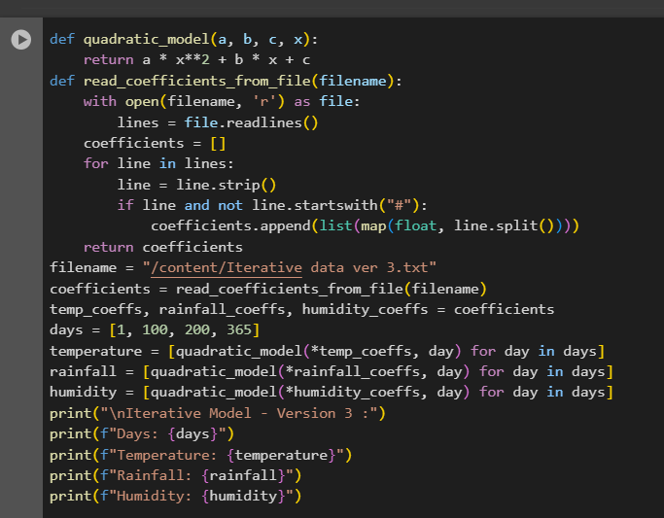

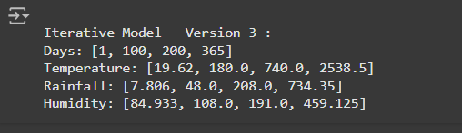

**d)Version 4 (Multiple sets of data):-**

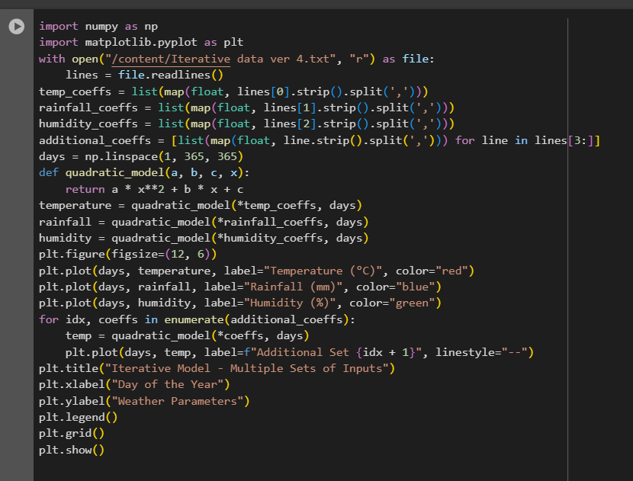

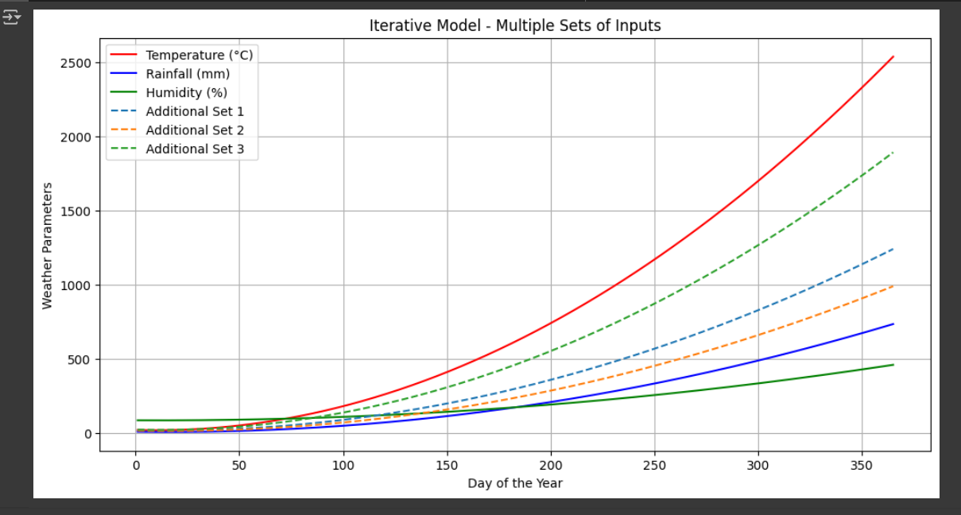

**GitHub Commit History:-**

**Version 1:-**

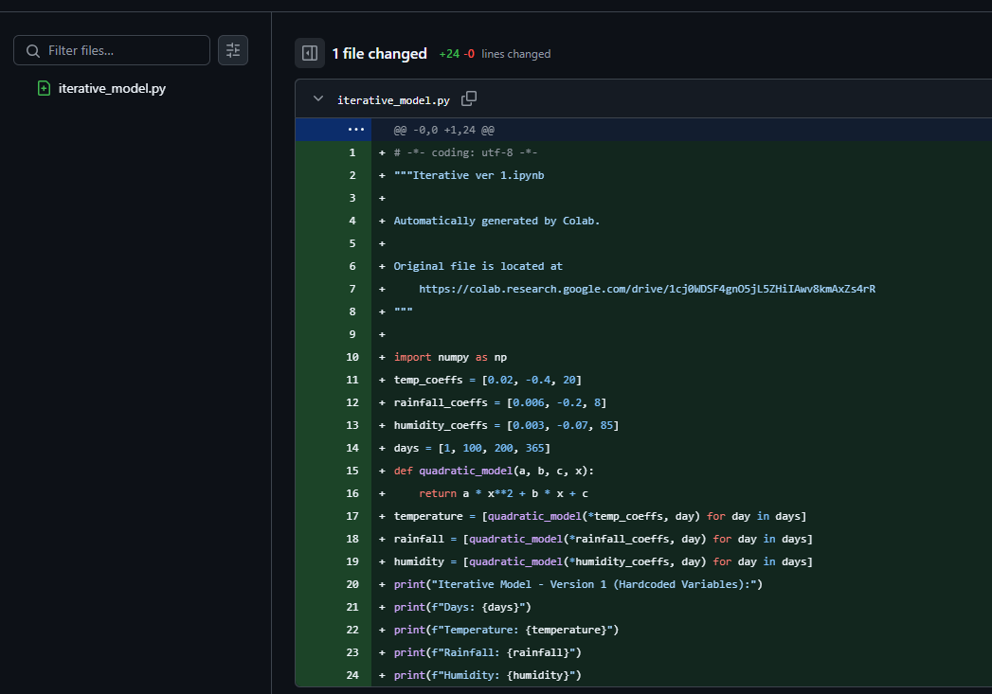

**Version 2:-**

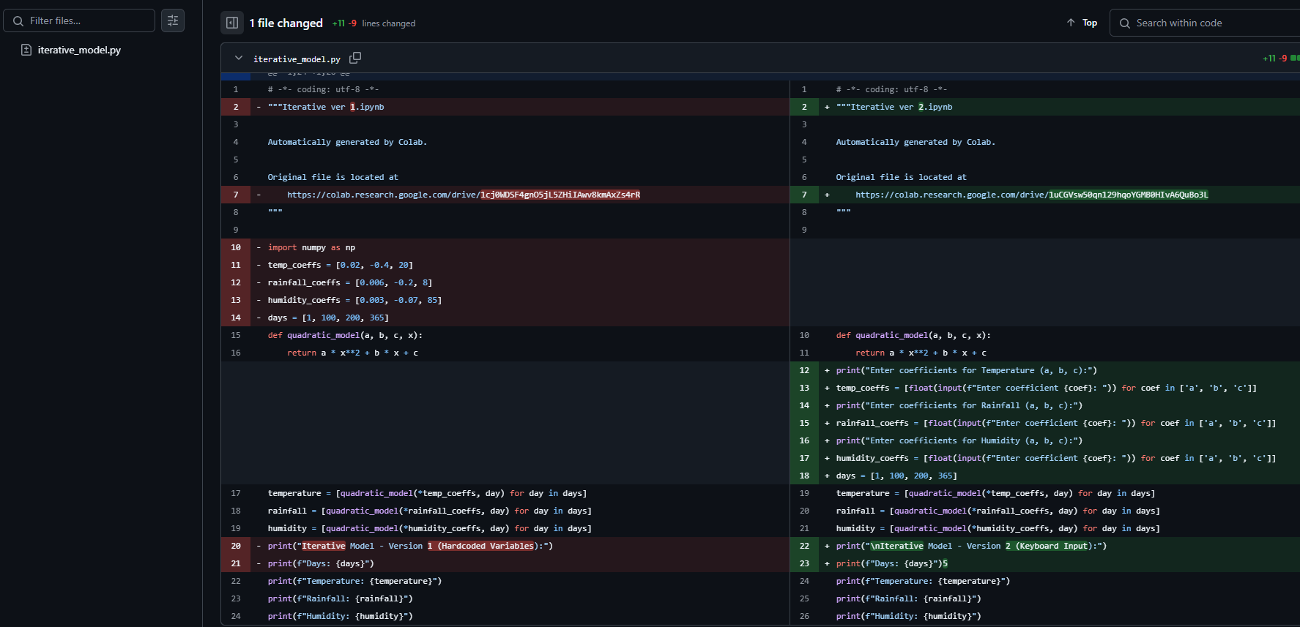

**Version 3:-**

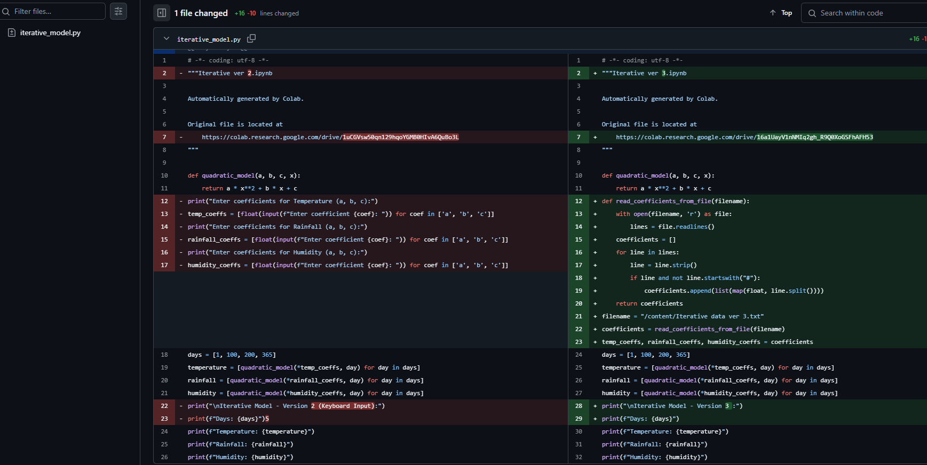

**Data ver 3:-**

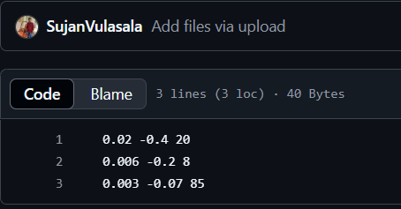

**Version 4:-**

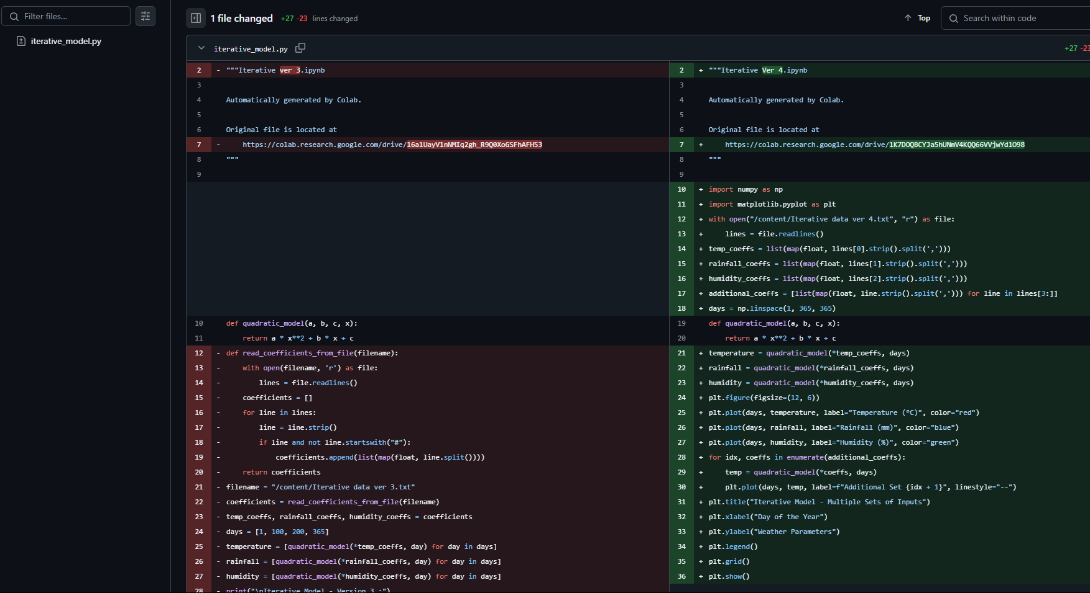

**Data Ver 4:-**

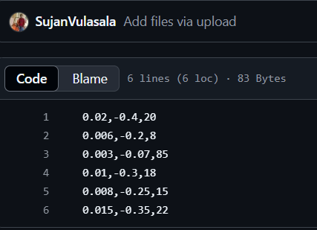

**3)Agile Method :-**

**a)Version 1(Hard coding variables):-**

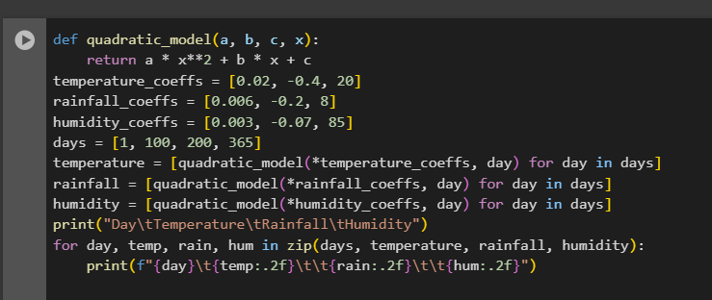

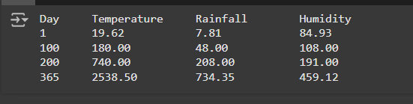

**b)Version 2 (Keyboard Input) :-**

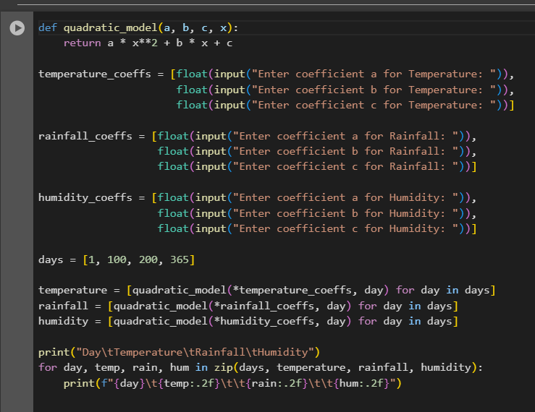

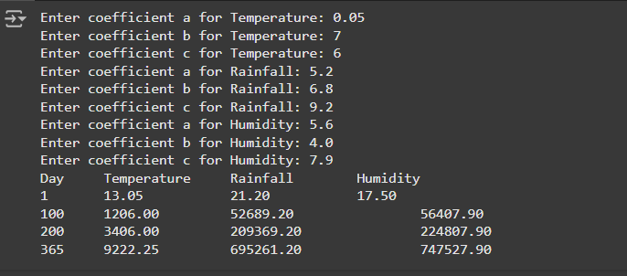

**c)Version 3 (Single set of data):-**

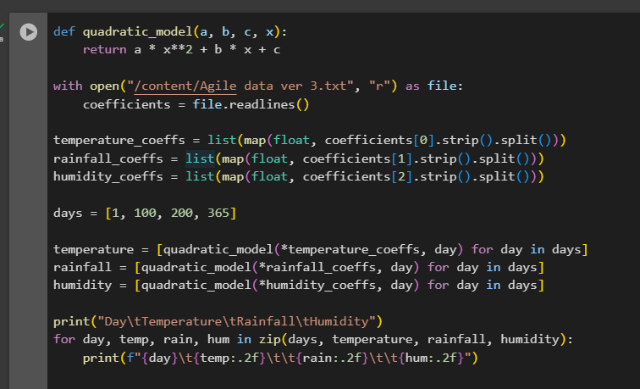 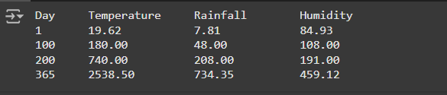

**d)Version 4 (Multiple sets of data):-**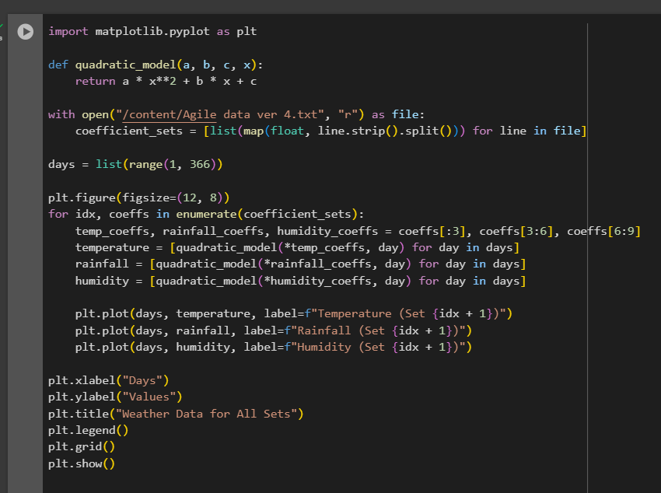 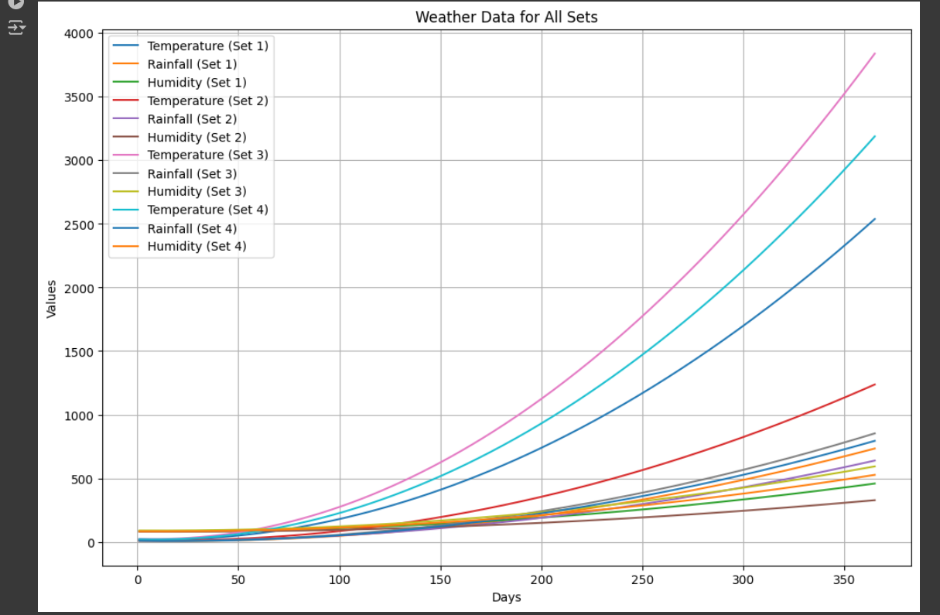

**GitHub Commit History:-**

**Version 1:-**

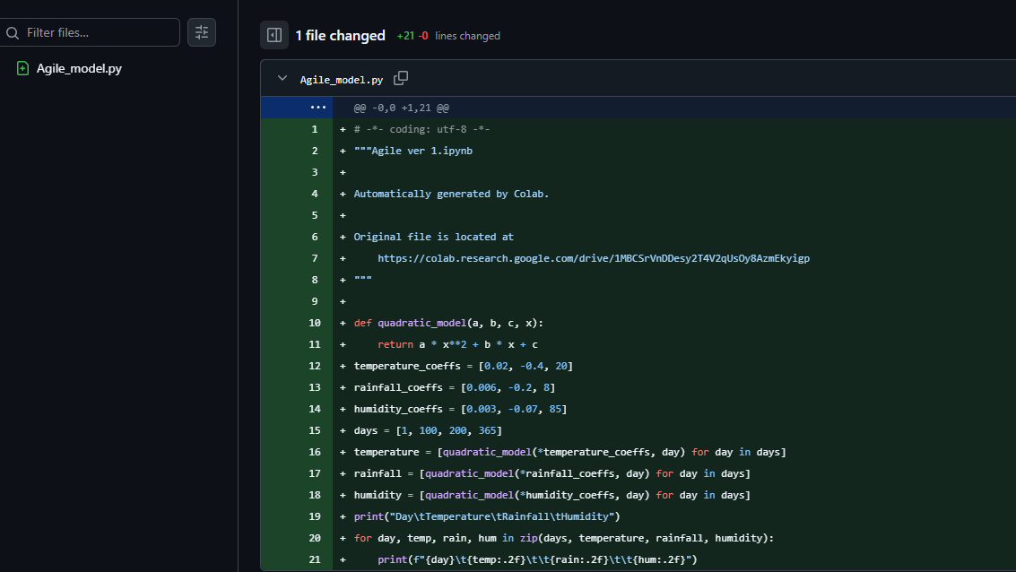

**Version 2:-**

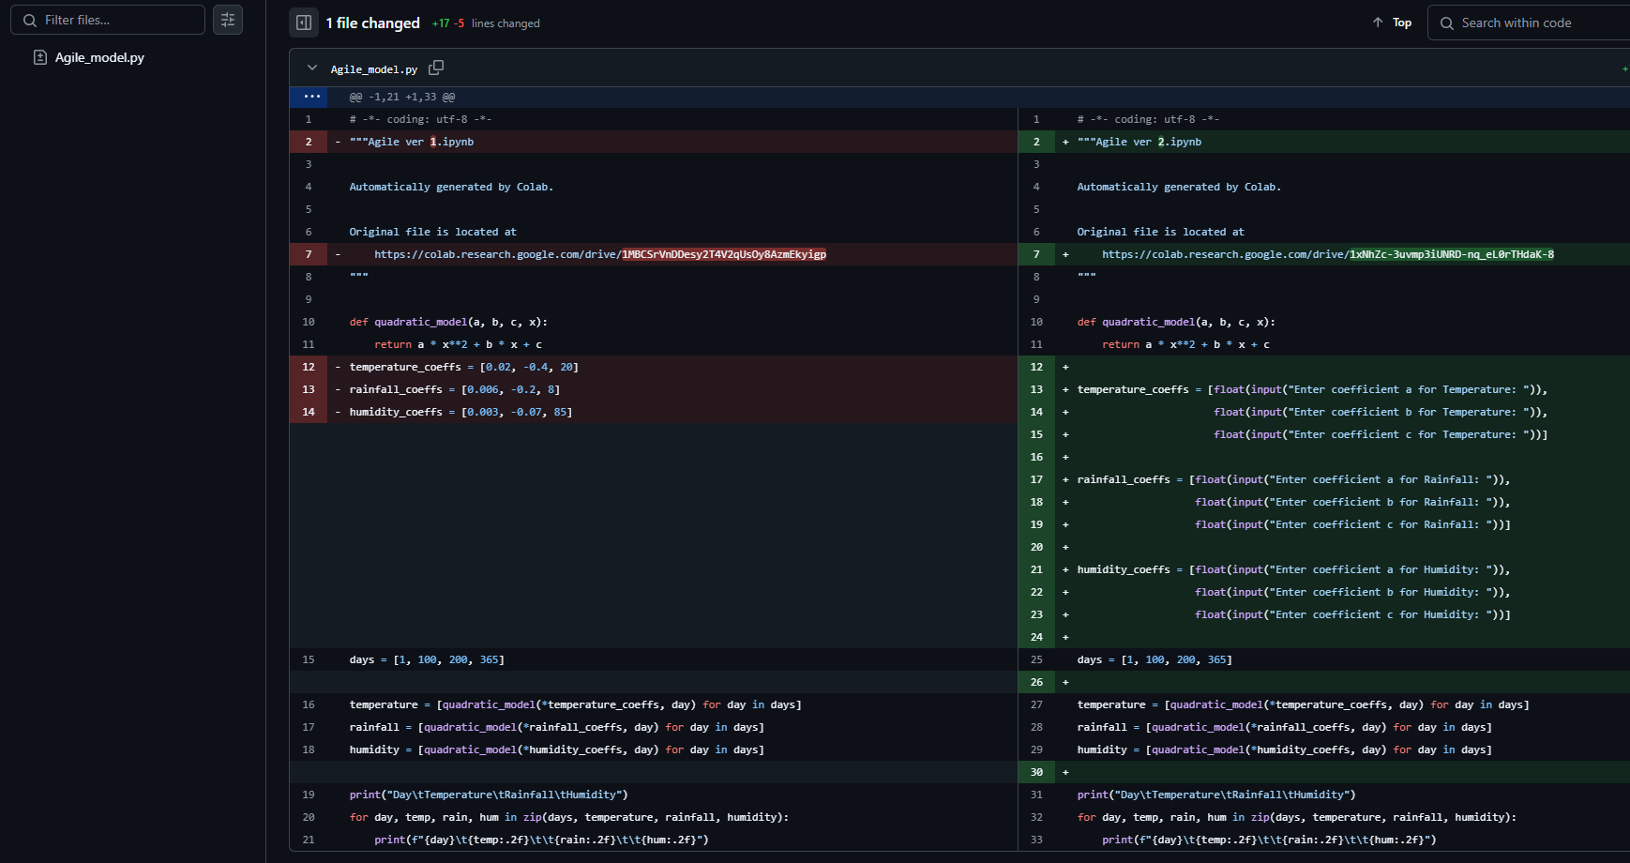

**Version 3:-**

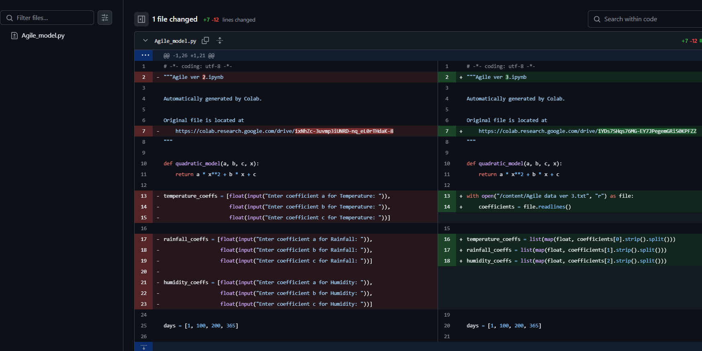

**Data ver 3:-**

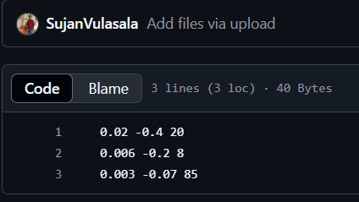

**Version 4:-**

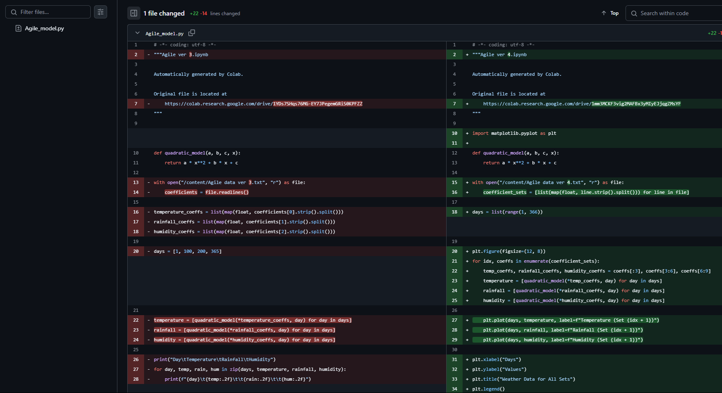

**Data Ver 4:-**

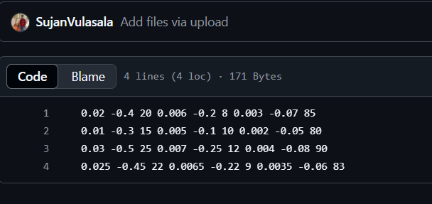

**Result :-**

The weather modelling system was successfully implemented using the quadratic solution. Each software development process approach (Waterfall, Iterative, Agile) was applied to demonstrate its implementation, testing, and delivery stages. All versions were saved on GitHub for version control, ensuring traceability and collaboration.